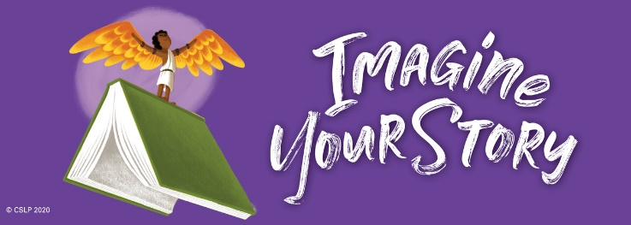
June 2020
Summer Reading Month
ZOO ANIMALS | Space | WEATHER | FOOD
SEASONS | NUMBERS | HEALTH | PETS
COLORS | SCIENCE | SPORTS | TRAVEL
TREES | NATURE | GAMES | FARM ANIMALS
Quitman Public Library!

Here’s how the GAME works:
It’s like BINGO! Check out and read a book on any of the subjects in the squares. Bring your books back in, and the librarian will stamp your squares.
- Get 4 in a row, column, or diagonally and get a FREE SONIC® ICE CREAM CONE
- Get all 16 squares to win a FREE SONIC® ICE CREAM CONE PLUS a pool pass to the Coach Delbert Ballard Memorial Pool in Quitman sponsored by Quitman – Lake Fork Kiwanis!
+
SEE WEEKLY ACTIVITY SCHEDULE ON BACK!

