libraries rock!

SUMMER READING 2017
Each Thursday in June

2 – 4 p.m.
Register now for Summer Reading!

Quitman Public Library
202 East Goode Street
Quitman TX 75783
903-763-4191
www.quitmanlibrary.org

ACTIVITY SCHEDULE for EACH
THURSDAY in JUNE 2 – 4 p.m.

7th Rocking the House with “Howdy-Do-Dat” at the Library! Howdy-Do-Dat is a ventriloquist, clown and magician.

14th 50s Sock Hop at the Library! Dale “The C” will be our DJ for a 50s sock hop. Activities: Freeze Dance – Who is Brave Enough to Sing a Song? – Dance Off!

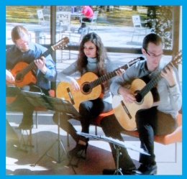
21st UT Classical Guitar Ensemble at the Library! Sara de la Rosa and her fellow classical guitarists will entertain. Activity: Draw how music makes you feel.

28th Making Music Together! We will make our own musical instruments and create our own orchestra!

Prizes will be awarded on June 28th, so bring your play card to show how many books you have read!

