SUMMER READING 2022
Each Wednesday in June

2 – 4 p.m.

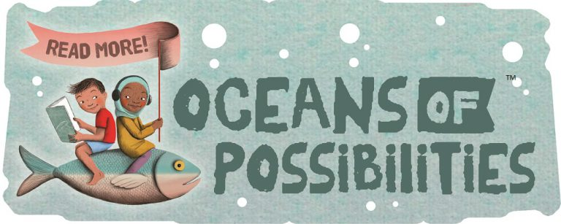

Register now for Summer Reading!

Quitman Public Library
202 East Goode Street
Quitman TX 75783
903-763-4191
www.quitmanlibrary.org

ACTIVITY SCHEDULE for EACH
WEDNESDAY in JUNE 2 – 4 p.m.

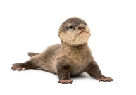
1st Kick-off Party with Baby Critters! We will discover “Oceans of Possibilities” learning about baby critters presented by the East Texas Zoo & Gator Park of Grand Saline, TX!

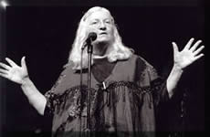
8th Award-winning Storyteller Elizabeth Ellis! As a nationally recognized storyteller, Elizabeth Ellis doesn’t miss a beat as she delivers stories that touch the heart and funny bone, riveting audiences of every age wherever she goes. Don’t miss this one!

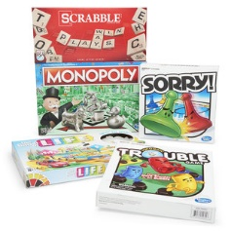
15th Board Game Casino! Come discover the fun of old-fashioned board games and table activities with games like Monopoly, Boggle, Trouble and Checkers! Volunteers from Forever Young Activity Center of Quitman will oversee the game tables.

22nd Hawaiian Hula Party! Hula dancers from Dance Dimensions in Mineola TX will perform and teach the hula. Sonic Ocean Water® drinks and pineapple snacks for everyone!

29th Popcorn and a 3-D Movie “The World Beneath the Ocean” at the library! 3-D Glasses will be provided. Prizes will be awarded this day, so bring your play card to show how many books you have read!

